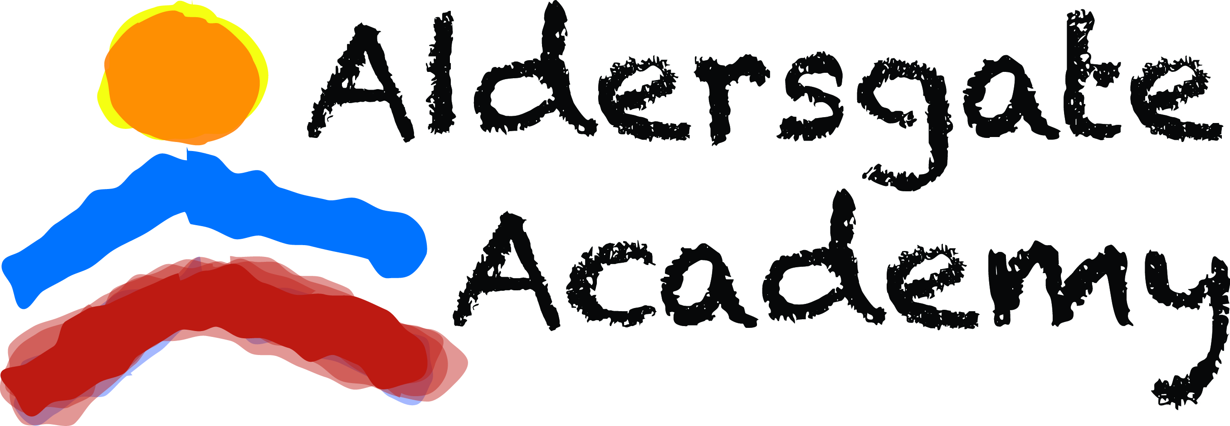
ALDERSGATE ACADEMY
2021-2022 ENROLLMENT AGREEMENTS

Child’s Name__________________________________________________________________________

Parent/Guardian’s Printed Name__________________________________________________________

Parent/Guardian’s Signature ____________________________________Today’s Date_______________

ENROLLMENT AGREEMENTS

Parent Handbook Acknowledgement
I acknowledge that I have a copy of the Aldersgate Academy Parent Handbook. I have reviewed all policies including the Discipline, Illness, and Emergency policies in the Handbook. I understand that I may contact the Director at any time with additional questions or concerns.
Hard copy _____ Online copy _____ Initials _____
Financial Agreement
I acknowledge the above stated tuition is due on Mondays. I understand that this tuition is due weekly throughout the school year, regardless of actual child attendance. I understand that a 2-week written notice is required prior to withdrawing. All payments plus any fees must be current. I acknowledge that a late fee of $20 is assessed on Tuesdays at 6:00 p.m. After two weeks of non-payment, a child may not return to class until payments are current.
Initials _____
Emergency Agreement
In the event of illness or accident, which requires immediate medical treatment, I give permission to the staff of Aldersgate Academy to seek such emergency treatment. This includes emergency transport and escort from the program to emergency facility. Your authorization gives us permission to share medical information with emergency personnel. We will attempt to contact the child’s parents, the child’s physician, and other emergency contacts.
Initials _____

Safe Transportation of Food/Snack Responsibility
If you bring food (snacks) to the Academy, it must be in unopened, store-purchased, and pre-packaged containers. This ensures that the food is sanitary for the children to consume. Upon receiving the food from the parent, the staff shall verify the temperature and condition of the food. Cold food should be at 41°F or below and hot food at 135°F or above. Staff cannot accept food that is not at the correct temperature. Upon accepting the food, the staff shall maintain correct temperatures until served.
Initials _____

Remind App
I agree to join the Remind App for important and emergency information concerning my child.

Initials _____

